**Polygenic Inheritance**

**I Objective:** In this lab we will analyze fingerprint patterns to determine patterns of polygenic inheritance in our classroom sample.

**II Principle:** While the rules of Mendelian inheritance hold true for many situations it does not explain them all. **Polygenic Inheritance** is a term used to describe cases where many genes contribute to an observed phenotype. This is in contrast to dominant/recessive situations in which one allele determines the phenotype exclusively. Examples of traits that have been described as polygenically inherited include; intelligence, height, fingerprint pattern and skin color. What this really means is that traits under polygenic control don’t often fall into discrete categories, i.e. they show continuous variation. Expression of polygenic traits are often markedly affected by the **environment**, causing them to be referred to as **multifactorial traits**.

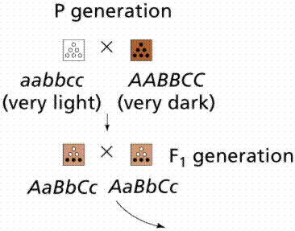

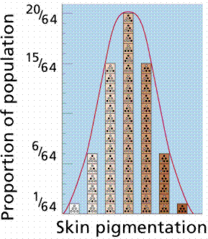

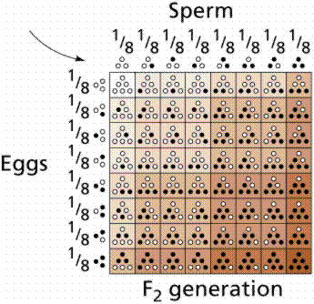

**Images from Purves *et al*., Life: The Science of Biology, 4th Edition, by Sinauer Associates**

The assumptions underlying the polygenic inheritance model include the following:

- The trait is controlled by many **independently assorting** loci.

- Each gene locus is represented by an active allele that contributes **an increment** or by an inactive allele that contributes **no increment**

- The alleles at each gene locus **lack dominance**, and each active allele has an effect on phenotype that is small and equal to that of each of the other active alleles affecting that trait.

- Phenotype is determined by the **sum** of all the active alleles affecting the trait.

- Finally, polygenes are not qualitatively different from other genes, they regulate the production of polypeptides and they **segregate and independently assort** according to Mendelian principles

**III. Procedure** Fingerprint patterns of dermal ridges can be classified into three major groups: arches, loops, and whorls. The **Arch** is the simplest and least frequent pattern. It may be subclassified as “plain” when the ridges rise slightly over the middle of the finger or “tented” when the ridges rise to a point.

The **Loop** pattern has a triradius and core. The **Triradius** is a point at which three groups of ridges, coming from three directions, meet at angles of about 120 degrees. The core is essentially a ridge that is surrounded by fields of ridges, which turn back on themselves at 180 degrees. Loops can be radial or ulnar. A finger possesses a **radial loop** if its triradius is on the side of the little finger for the hand in question and the loop opens toward the thumb. A finger has an ulnar loop if its triradius is on the side of the thumb for that hand and the loop opens toward the little finger. The **whorl** pattern has two triradii, with ridges forming various patterns inside. The frequencies of these fingerprint pattern types in the general population are as follows: arch 5.0%, radial loop, 5.4%, ulnar loop 63.5%, and whorl 26.1%.

**Determining ridge count.** The focus of this investigation is the polygenic or quantitative trait called the **total ridge count** (TRC), the sum of the ridge counts for all 10 fingers. The average TRC for males is 145, and for females is 127.

For an arch, the ridge count is 0. The ridge count on a finger with a loop is determined by counting the number of ridges between the triradius and the center or core of the pattern. For a whorl, a ridge count is made from each triradius to the center of the finger print, but only the higher of the two possible counts is used.

**Method**

1. Prepare your fingerprints by rolling your finger gently in the ink pad then repeating the rolling motion on the index card to make a full fingerprint.

2. Prepare a finger print for each finger on both hands.

3. Using a dissecting microscope (if needed), determine your TRC using the below diagram. Each fingerprint must be first classified by type (Arch, Radial or Ulnar Loop, Whorl) before counting can begin.

4. Label the index card with the fingerprint type and ridge count for each finger. Also note the total TRC for each hand.

**Three principle types of fingerprint patterns**

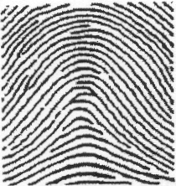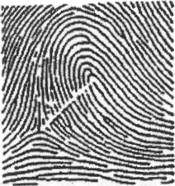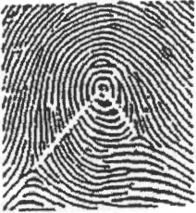

A B C

Three principle types of fingerprint patterns: (A) Arch with no triradius and a ridge count of 0. (B) Loop with one triradius and a ridge count of 12, and (C) Whorl with two triradii and a ridge count of 15 (the higher of the two possible counts).

5. The data will be compiled on the board in the following format:

|  |  |  |  |  |  |
| --- | --- | --- | --- | --- | --- |
| **Number of fingers having:** | | | | | |
| **student** | Loop | Whorl | Arch | TRC | Gender |
| **1** |  |  |  |  |  |
| **2** |  |  |  |  |  |
| **3** |  |  |  |  |  |
| **…24** |  |  |  |  |  |
| **totals** |  |  |  |  |  |
| **Percentages of totals** |  |  |  |  |  |
| **Mean TRC** |  |  |  |  |  |
| **Mean TRC females** |  |  |  |  |  |
| **Mean TRC males** |  |  |  |  |  |

**A model for polygenic fingerprint inheritance:** Total fingerprint ridge count exemplifies a polygenic inheritance pattern. It has been suggested that a minimum of seven gene loci contribute to TRC. Under this model, active alleles would additively contribute to the observed phenotype while inactive alleles would contribute nothing.

**TRC Assignment:** Using the classroom data and the paper titled “GENETICS OF DERMAL RIDGES: FREQUENCY DISTRIBUTIONS OF TOTAL FINGER RIDGE-COUNT” found on the genetics webpage “background materials” link, please answer the following questions.

1. Construct a histogram in the style of Holt (1952). (Excel or any statistical software can do this)

2. How does the class’s average TRC for each gender compare with Holt’s (1952) data?

3. How does your personal TRC compare with the class average and Holt’s (1952) data?

3. Why are the classroom averages different (they likely are…) from Holt’s (1952) data? What could explain the variation between your data and Holt’s (1952) data?

4. Using your knowledge of development, genetics, and biology, explain a possible reason why males and females have a different TRC. To answer this question correctly you will probably need to consider many aspects of human biology and synthesize a coherent explanation.

5. In what ways is Mendelian genetics different from polygenic inheritance?

6. In what ways are the two models of inheritance the same?

Bonus: Unfortunately, the χ2test is mathematically unsuitable for use with averages. What statistical test could we use to determine if our average TRC is really the same as Holt’s (1952) data?